**[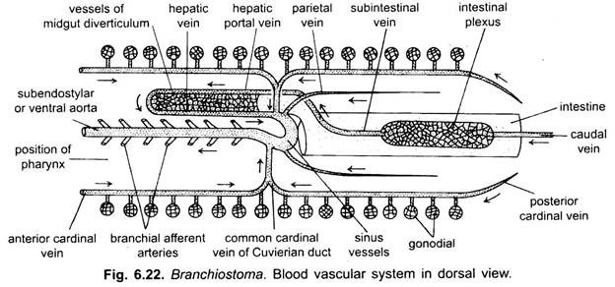](http://www.notesonzoology.com/wp-content/uploads/2017/07/clip_image004-14.jpg)**

